**1. Name and ID Numbers of the Owners**

Steven Kalungu Kikwa – ID 32865857 , Phone +254715135503

Abdulnaim Mohamed

Bilal Hussein

Mohamed Onyango

Najma Bashir

**2. Abstract**

**a) Purpose of the Software**  
The Mammary Protect app is designed to work alongside the Mammary Protect device, providing an innovative breast cancer screening solution. The app processes thermography and ultrasound images to help users detect early signs of breast cancer. It integrates with wearable technology and uses machine learning to classify scans as benign or malignant, guiding users towards timely medical consultation.

**b) Technologies Used**  
The app is built using machine learning models for image classification, Python for model development, and TensorFlow/Keras for neural network training. It integrates cloud-based services via AWS for secure storage and model updates. The frontend is developed using Flutter for cross-platform compatibility.

**c) Platforms**  
The Mammary Protect app runs on Android and iOS platforms. The data and model training process are managed via cloud-based services on AWS, allowing for continuous updates and storage of medical records.

**3. Introduction**

The Mammary Protect app is a companion software for the Mammary Protect breast cancer screening device. It functions as both a health monitoring tool and an interface for viewing scan results. Users can upload thermography and ultrasound images taken by the device, and the app utilizes a pre-trained machine learning model to classify the results as either benign or malignant. The app is user-friendly, with a simple login process, and provides intuitive guidance through each step of the scanning process.

Key functionalities include:

* **Image Upload**: Users can upload scans captured from the Mammary Protect device.
* **Image Classification**: The app processes uploaded images and provides immediate feedback (benign or malignant).
* **Health Tips**: Provides tips on breast cancer prevention and self-examination.
* **Data Security**: Ensures secure storage of sensitive health data using cloud encryption.
* **Subscription Model**: Offers premium features, including detailed analysis and health updates.

**4. Actual Documentation**

**a) Accessing the App**  
To access the Mammary Protect app:

* Users download the app from either the Google Play Store (Android) or the Apple App Store (iOS).
* Upon opening the app, users are greeted by a sign-up/login page where they can create an account or log in using their credentials.  
  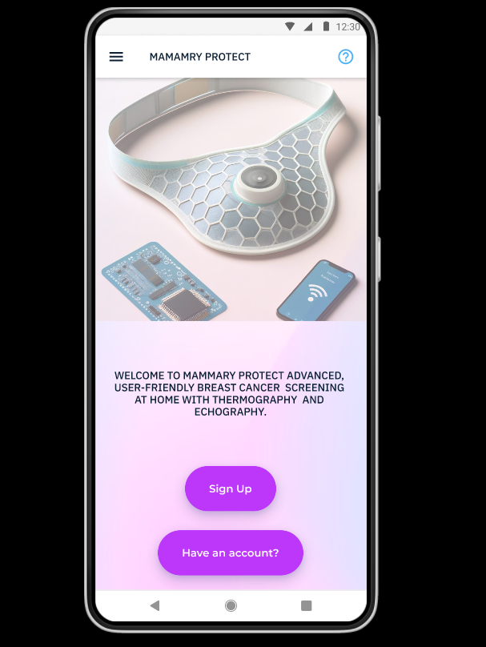
* After successful login, users are directed to the home page which provides options for uploading images, viewing scan history, or checking health tips.  
  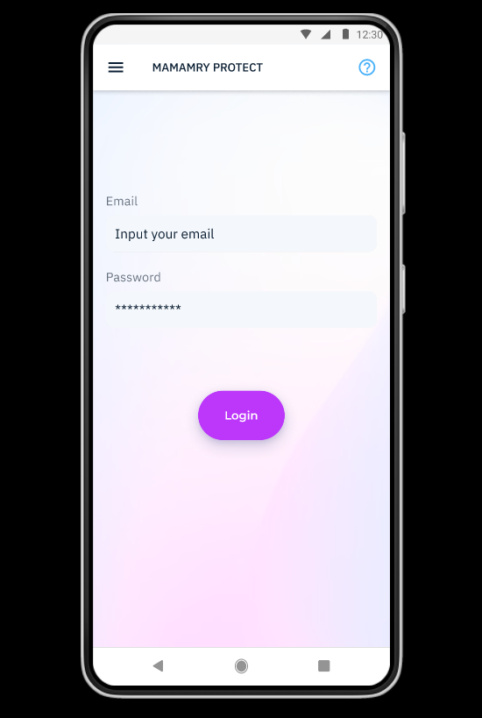

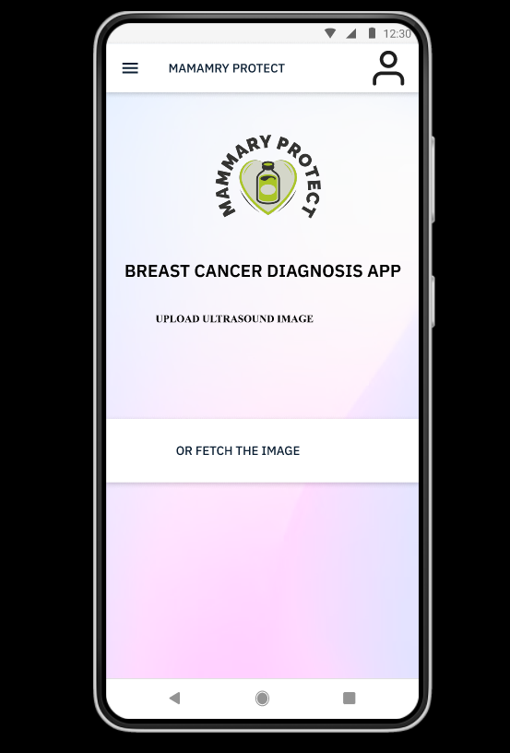

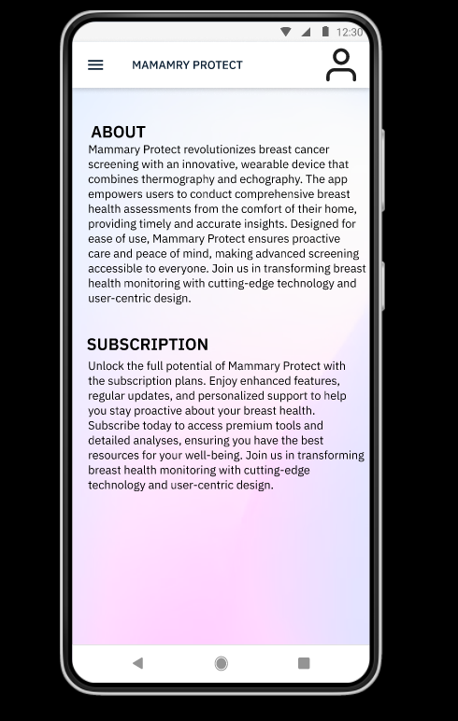

**b) Key Interfaces**

* **Home Page**: Displays options for image upload, scan history, and health tips.
* **Upload Interface**: Allows users to upload images from their device, selecting either thermography or ultrasound images for analysis.  
  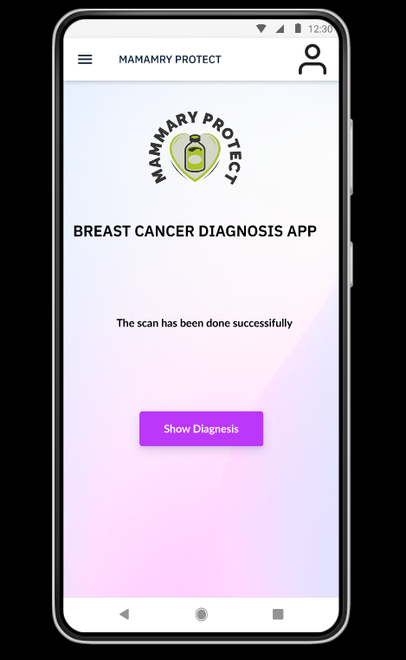
* **Results Interface**: After processing the image, the app provides the user with a clear result—either "you are at high risk" or "You are at low risk".  
  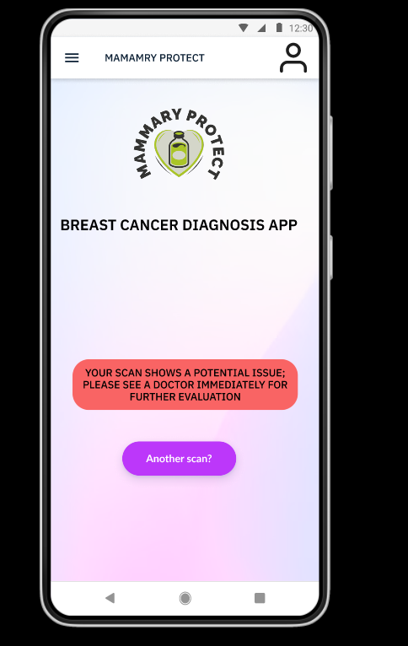
* **Health Tips Section**: Provides users with educational content on breast cancer prevention and early detection.  
  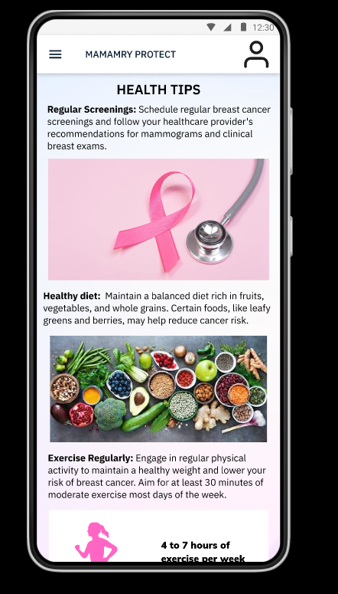

**c) Key Source Codes**  
Include the most relevant sections of the source code that pertain to the core functionalities, such as:

* Image upload processing
* Machine learning model integration (using TensorFlow)
* Result classification algorithms
* User authentication and data storage

Attached below is the program flowchat. For more interaction with the app you can visit the link below to see the prototype design ([Mammary Protect](https://www.figma.com/proto/8ab7WLgUTTUh05qpjLhE9R/Untitled?page-id=0%3A1&node-id=1-3&node-type=frame&viewport=182%2C355%2C0.14&t=lM8dKM1A20GGmHVk-1&scaling=scale-down&content-scaling=fixed&starting-point-node-id=12%3A867&show-proto-sidebar=1))

